LAB EXPERIMENT RECORD

SET 29: STUDENT PERFORMANCE AND PARTICIPATION ANALYSIS

Department | AIDS
Course | DSA0206 / Data Handling and Visualization
Experiment | Data Visualization using R
Name | M.Teja kumar
Register Number | 192424308
Date | 15 OCTOBER 2026
Day | Thursday

Aim
To visualize student test scores, participation scores, and study hours by attendance quartile using RStudio, and to describe an interactive dashboard for exploring student performance.

Datasets
Dataset A — Student test and participation scores

Student ID | Test Score | Participation Score
S1 | 85 | 8
S2 | 70 | 7
S3 | 92 | 9
S4 | 80 | 8
S5 | 65 | 6
Dataset B — Study hours and attendance quartile (as shown in the supplied screenshot)

Student ID | Study Hours | Attendance Quartile
S1 | 8 | Q1
S2 | 10 | Q2
S3 | 15 | Q4
S4 | 12 | Q3
S5 | 7 | Q1

PROGRAM 1: Density Plot of Test Scores
Objective: Display the distribution of student test scores using a kernel density estimate and rug marks.
data <- data.frame(Student_ID = paste0("S", 1:5),
Test_Score = c(85, 70, 92, 80, 65)) plot(density(data$Test_Score),
main = "Density Plot of Test Scores", xlab = "Test Score", ylab = "Density", col = "blue", lwd = 2)
polygon(density(data$Test_Score), col = "lightblue", border = "blue")
rug(data$Test_Score, col = "red", lwd = 2) print(data)

Procedure: Create the data frame, compute the kernel density estimate, draw the filled density curve, and add rug marks at the observed test scores.

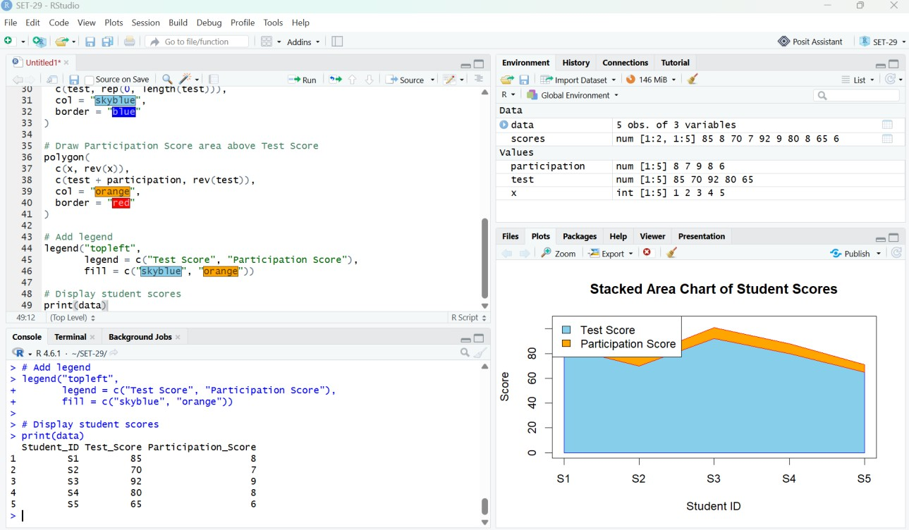

Figure 1. RStudio density plot of test scores.

Observation: Test scores range from 65 to 92. The density curve is a smoothed representation of five scores; it should not be interpreted as a population distribution.

PROGRAM 2: Stacked Area Chart of Test and Participation Scores
Objective: Compare student test scores and participation scores in a stacked area visualization.
data <- data.frame(Student_ID = paste0("S", 1:5),
Test_Score = c(85, 70, 92, 80, 65),
Participation_Score = c(8, 7, 9, 8, 6))
x <- 1:nrow(data)
test <- data$Test_Score
participation <- data$Participation_Score plot(x, test + participation, type = "n",
xaxt = "n", xlab = "Student ID", ylab = "Score", main = "Stacked Area Chart of Student Scores", ylim = c(0, max(test + participation) + 5))
axis(1, at = x, labels = data$Student_ID) polygon(c(x, rev(x)), c(test, rep(0, length(test))),
col = "skyblue", border = "blue")
polygon(c(x, rev(x)), c(test + participation, rev(test)), col = "orange", border = "red")
legend("topleft", legend = c("Test Score", "Participation Score"), fill = c("skyblue", "orange"))
print(data)

Procedure: Create both score vectors, plot the total heights, fill the test-score area from zero, then stack the participation area above the test scores.

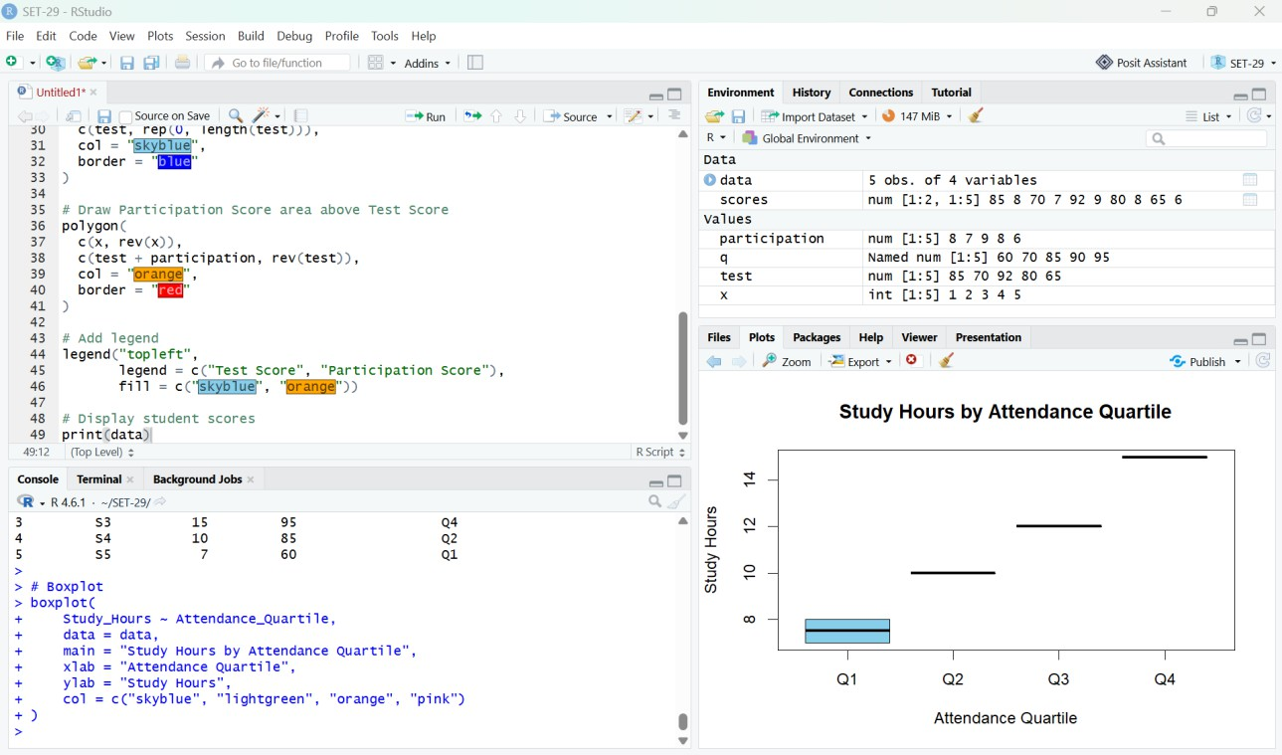

Figure 2. RStudio stacked area chart of student scores.

Observation: Student S3 has the highest test score (92) and participation score (9); S5 has the lowest (65 and 6). The two scores have different scales, so stacking is illustrative rather than a normalized comparison.

PROGRAM 3: Boxplot of Study Hours by Attendance Quartile
Objective: Explore study hours grouped by attendance quartile.
data <- data.frame(
Student_ID = paste0("S", 1:5), Study_Hours = c(8, 10, 15, 12, 7),
Attendance_Quartile = factor(c("Q1", "Q2", "Q4", "Q3", "Q1"),
levels = c("Q1", "Q2", "Q3", "Q4"))
)
boxplot(Study_Hours ~ Attendance_Quartile, data = data, main = "Study Hours by Attendance Quartile",
xlab = "Attendance Quartile", ylab = "Study Hours", col = c("skyblue", "lightgreen", "orange", "pink"))
print(data)

Procedure: Create the study-hours dataset, order quartile categories Q1 through Q4, and generate a grouped boxplot.

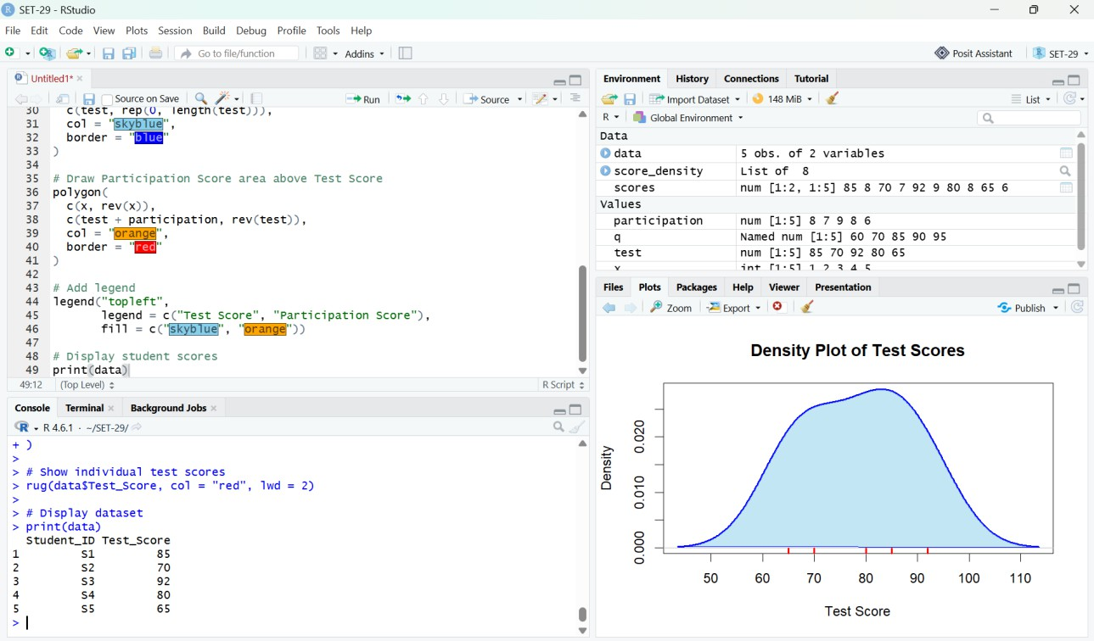

Figure 3. RStudio boxplot of study hours by attendance quartile.

Observation: Q1 contains two students studying 7 and 8 hours. Q2, Q3 and Q4 each contain only one student, so their boxplots appear as horizontal lines. A larger sample is needed to assess variability.

PROGRAM 4: Interactive Dashboard (Tableau)
Procedure: Export the two datasets from R as CSV files; open them as separate Tableau data sources. Build a test-score view by Student_ID, a participation-score view, and a study-hours view by Attendance_Quartile. Arrange these worksheets on a dashboard and add Student_ID filters where the data sources are appropriately related.
write.csv(data.frame(Student_ID = paste0("S", 1:5),
Test_Score = c(85, 70, 92, 80, 65),
Participation_Score = c(8, 7, 9, 8, 6)), "SET29_Student_Scores.csv", row.names = FALSE)
write.csv(data.frame(Student_ID = paste0("S", 1:5),
Study_Hours = c(8, 10, 15, 12, 7),
Attendance_Quartile = c("Q1", "Q2", "Q4", "Q3", "Q1")), "SET29_Attendance.csv", row.names = FALSE)

Result: The Tableau dashboard procedure supports interactive exploration. No Tableau dashboard screenshot was supplied, so this section documents the steps rather than claiming it was executed.

Overall Procedure
- Enter the student datasets into RStudio.
- Run Program 1 and inspect the density plot.
- Run Program 2 and inspect the stacked area chart.

- Run Program 3 and inspect the grouped boxplot.
- Export CSV files and build the Tableau dashboard using the provided instructions.

Overall Result
The three supplied RStudio outputs demonstrate a test-score density plot, a stacked area chart of test and participation scores, and a boxplot of study hours by attendance quartile. These visualizations support exploratory analysis of the five student records.

